Home Work 1 (2007-09-10)
Submission deadline: 2007-09-17

Question 2:
i). Give an account of advantages and disadvantages of inheritance and composition.

Composition
Advantages:
- Contained objects are accessed by the containing class solely through their interfaces
- “Black-box” reuse, since internal details of contained objects are not visible
- Good encapsulation
- Fewer implementation dependencies
- Each class is found on just one task
- The composition can be defined dynamically at run-time through objects acquiring references to other objects of the same type
Disadvantages:
- Resulting systems tend to have more objects
- Interfaces must be carefully defined in order to use many different objects as composition blocks

Inheritance
Advantages:
- New implementation is easy, since most of it is inherited
- Easy to modify or extend the implementation being reused
Disadvantages:
- Breaks encapsulation, since it exposes a subclass to implementation details of its superclass
- “White-box” reuse, since internal details of superclass are often visible to subclass
- Implementations inherited from superclass can not be changed at run-time

ii).Give an example of when inheritance is better and when composition is better
Composition is used in such way that you want the features of a ready-made class inside your class, which means you embedded an object and use it to implement functionally in your new class. By making embed objects private, the user of your new class sees the interface you’ve defined, instead of the interface from embedded object.

On the other hand, inheritance utilizes an existing class and makes a particular version of it. You take a general-purpose class and specialize it for certain need.

In all, inheritance stands for the “is a” relationship, and composition presents the “has a” counterpart.

Question 4:
Draw a class diagram for the case of our course. We assume that there are at least the following classes: Person, Student, Instructor and Assistant (you can add as many additional classes as you would like). You should draw associations between them, possible attributes and operations.

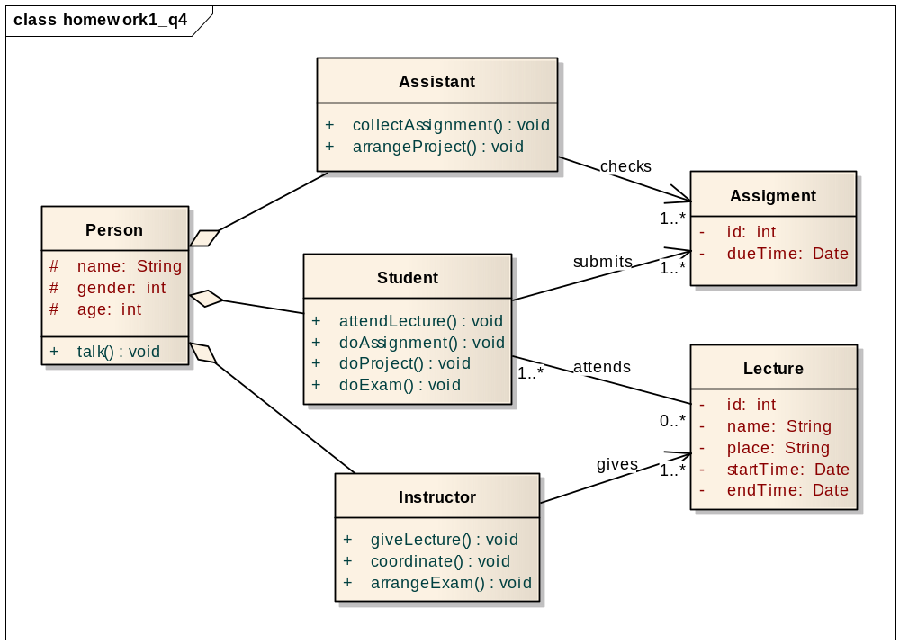

There are two reasons, we flavor composition over inheritance. First of all, a student is a role a person plays (rather than “is a special kind of “), so are instructor and assistant. Secondly, an instance of a subclass of Person could change from Student to Instructor or assistant over time, and vice versa.

Question 6:
Draw a class diagram for a part of a Car Sharing System, based on a personal interview transcript. Identify any aggregation associations.
Andres: Just remind me, what kind of things do you need to know about the start and the destination of each journey?
Mihhail: We'd want to know the building name and number, the apartment number, the street, town or city, county and postal code or zip code. We'd also want to hold similar information for the home adress of the sharer as well.
Andres: OK. Didn't you say that the journey start and destination address will be used to match up possible shared journeys?
Mihhail: Yes -interesting point that. I'm not quite sure how you'll do this. We want to be able to establish whether two addresses are close enough to each other to be able to consider them a match for a shared journey. For example, two people may want to get from a start destination on adjacent corners of two different blocks to destination addresses in different floors of the same building. A person looking at the addresses would know that the addresses are similar enough to be a match, but in terms of just text of the addresses, they look completely different.

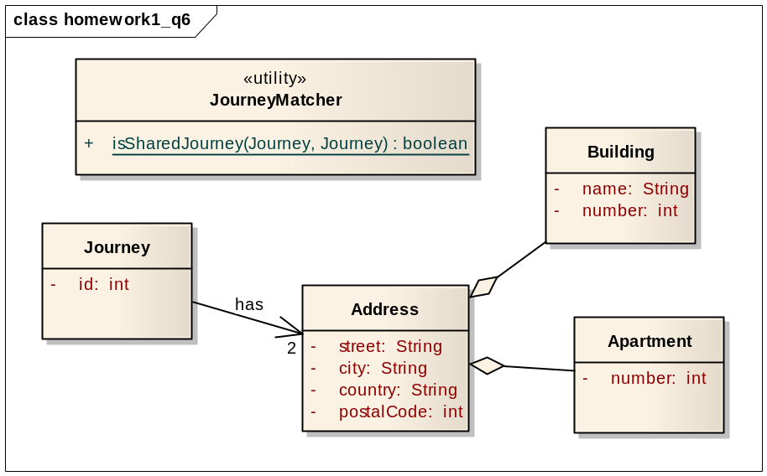

Each journey is composed of two addresses: start and destination, while each address owns a specific building and apartment to further identify its uniqueness, and a utility class is introduced to accomplish the task of matching shared journey.

Question 8:
Draw a sequence diagram of scenario “WarehouseOnFire” given in figure 2-15 in Book.
Include Objects bob, Alice, john, FRIEND and instances of other classes you may need.

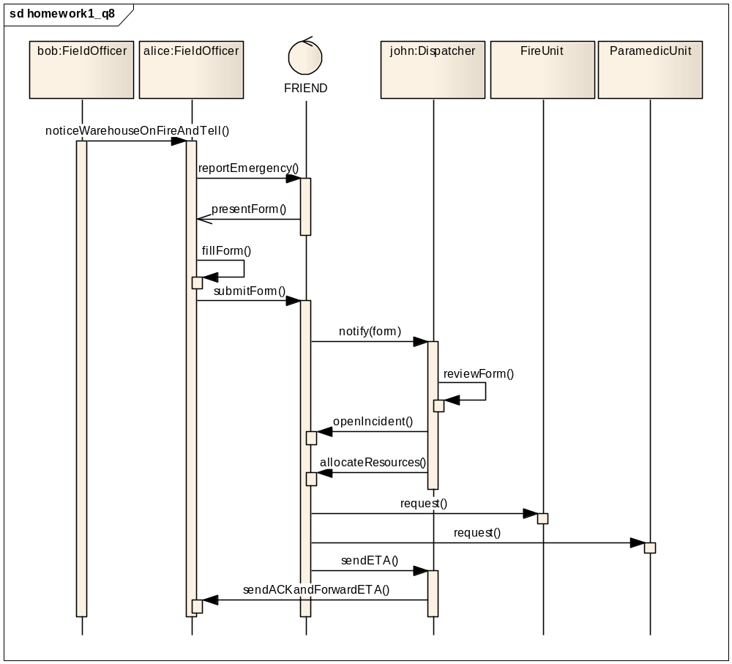
The “WarehouseOnFire” scenario begins with the notification of fire by Bob, ends when Alice receives the acknowledgment and the ETA. Since “FRIEND” is an accident management system, we denote it as a control, which is active component that controls what work gets done, when and how. It interacts with the fieldofficer and the dispatcher, and communicates with other resources/systems (FireUnit, ParamedicUnit).

Question 10
Draw an activity: "Opening account, deposit/withdraw iterations (with conditions checking) and closing account” as state chart diagram(s).

The three activities are illustration in three separate state chart diagrams, as following:

1) Opening accont
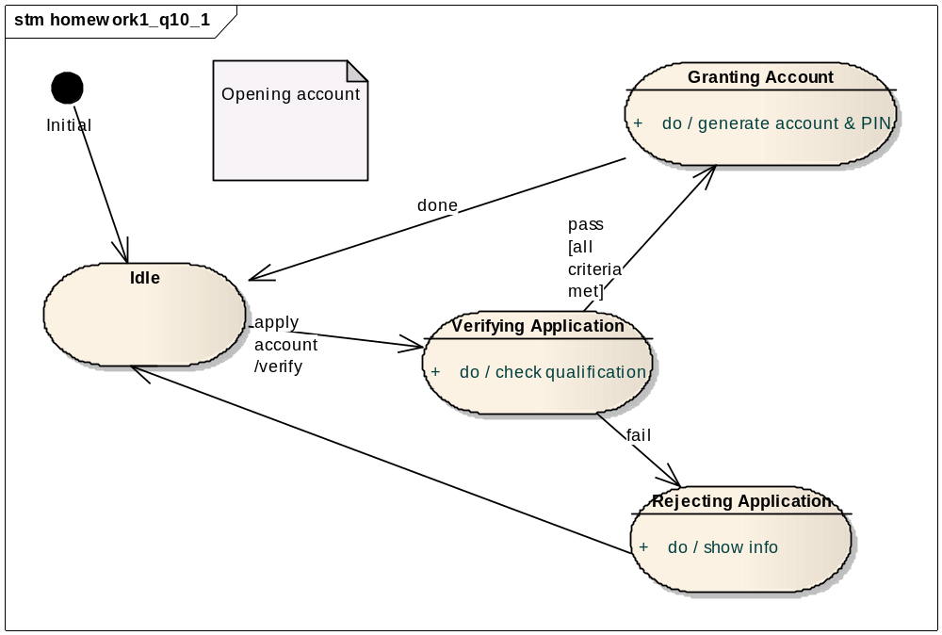
Assume there is account opening subsystem, and normally it is idle, waiting for request. When the event of applying a new account is coming, it triggers the verification action, thereby enters the verifying state. Then the system checks the qualification of applicant again some criteria, if it matches the account number and PIN code will be generated in granting account state, otherwise the application is rejected, and eventually the system returns to idle state.

2) Deposit/withdraw iterations
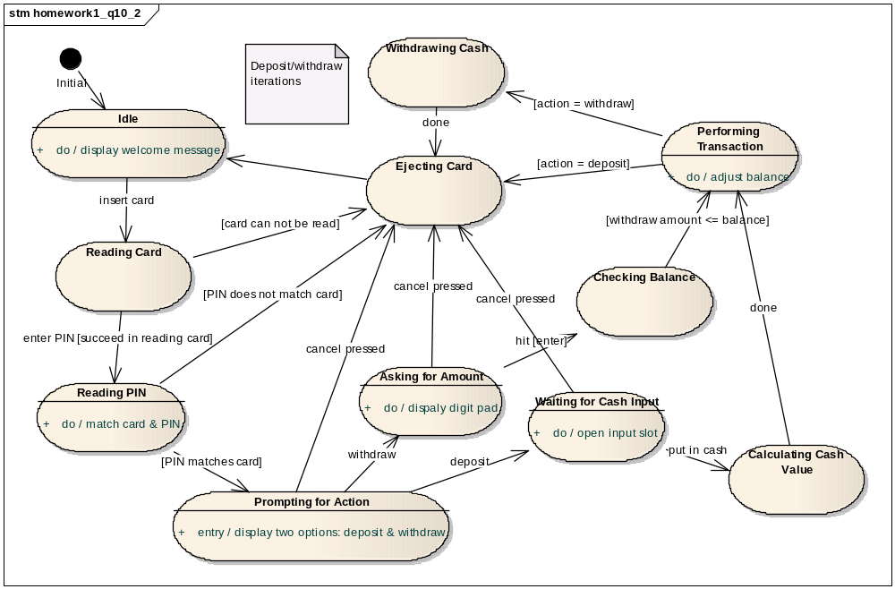
Unlike opening or closing account, here let’s think about an ATM machine, on which we can withdraw and deposit (thought it is weird). The state chart diagram above is detailed enough to complain itself, the two iterations start with reading card and PIN code, set apart after prompting for action state (asking user to select between withdraw action and deposit action), and finally converge when coming to ejecting card state.

3) Closing account
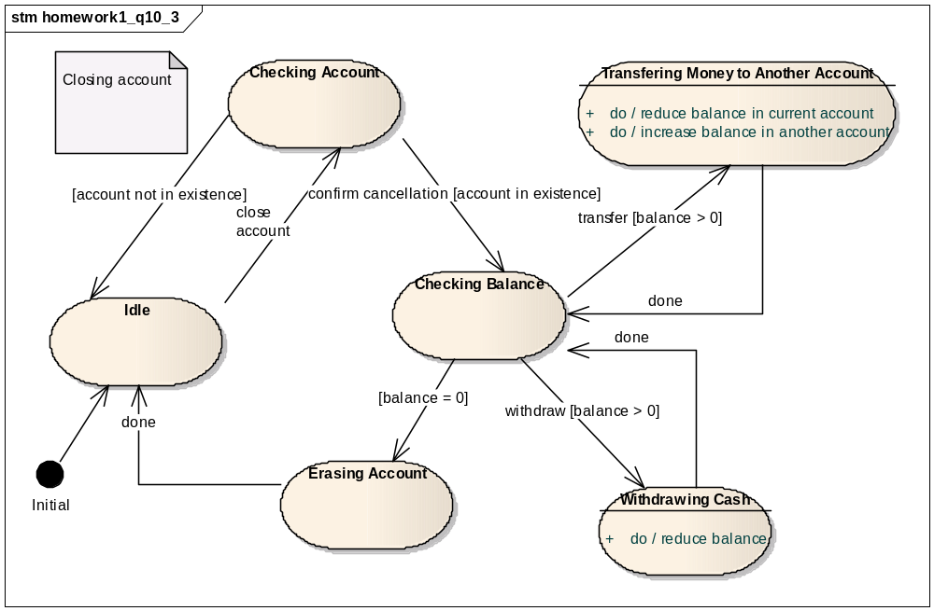
Similar to opening account scenario, we figure out an account closing subsystem, as usual it settles in idle state at the beginning. When the system receives a close account event, it first checks whether the specific account exits or not, if there is no such account, the system goes back to idle, otherwise it waits for confirmation of cancellation, for safety sake, to proceed to balance checking state, where the system tries to clear the balance by either transferring or withdrawing, once balance becomes zero, it enters the state where all necessary operations are carried out to erase the account indeed.

Question 12
Draw activity diagram of Boehm’s Spiral Model in Figure 15-10. (01 Bonus Point)

We depict Boehm’s spiral model by a parent and a child activity diagrams.
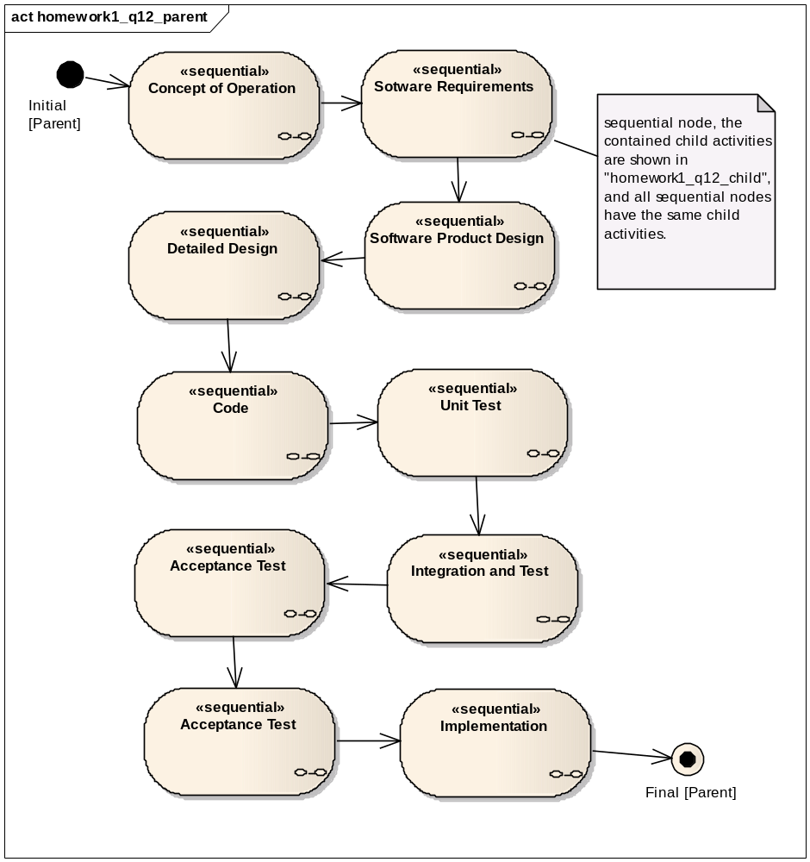

In Boehm’s spiral model, there’re mainly 9 rounds, which are presented as a set of sequential nodes in the parent activity diagram above, starting from “Concept of Operation” till “Implementation”. Each and every sequential node represents a sequential arrangement of activities, and in this case, all nodes have the same child activities as defined in Boehm’s spiral model, which are depicted in the child activity diagram below.

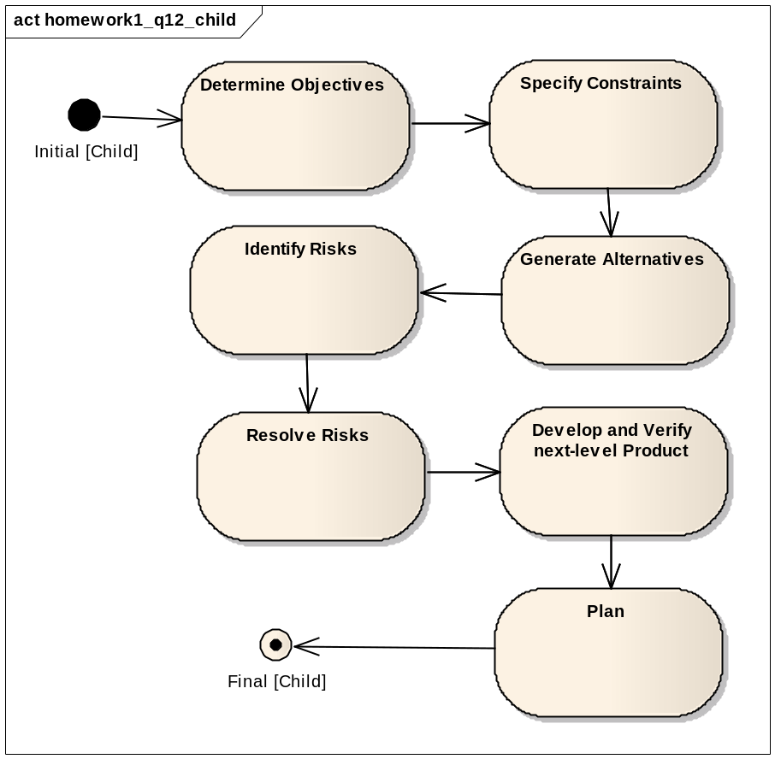
In Boehm’s spiral model, each round goes through the waterfall model, including “Determine Objectives” to “Plan”, so we define the above child activity diagram to hold such flow, and this flow is embedded in every sequential node in parent diagram. Then by putting these two diagrams together, it reveals a gradual iteration as a spiral model.

